Community Development Grant Five Year Plan

Village Objective: The village seeks to have a more scenic experience that is accessible to both community members inside and outside our village. By improving our existing infrastructure and interconnecting them all via paved and ADA accessible walking paths we can better strive towards that goal. Please find below projects that seek to improve accessibility to village trails and park land, improve village park infrastructure, and a plan to connect under served sections of our community via a trail extension.

2026- Pave parking lot at the Meadow Steet parking area. Project would consist of installing storm drainage to the parking area, adding ADA sidewalks to the trail head of the Southeast Community Park trail, handicap parking stalls and paving the gravel area.

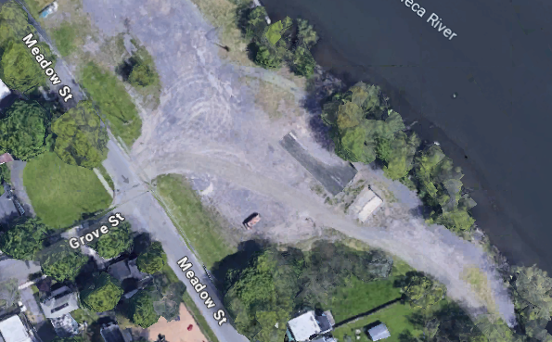

2027- Remove and replace existing playground equipment at McHarrie Park. Add ADA accessible fixtures, pathways and equipment for a more inclusive community playground experience.

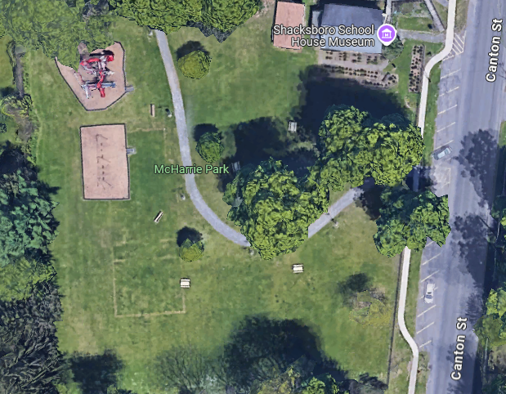

2028- Repair Roof on Amphitheater at Paper Mill Island. Roof has been leaking for 3 years and needs inspection and at the minimum a patch to stop the water infiltration.

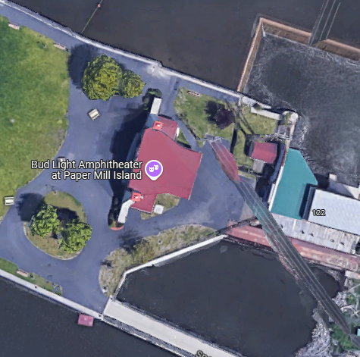

2029- Mill Island Trail Rehabilitation. Cut back overgrowth in trail, regrade uneven walking surfaces, bring trail to current ADA standards and pave.

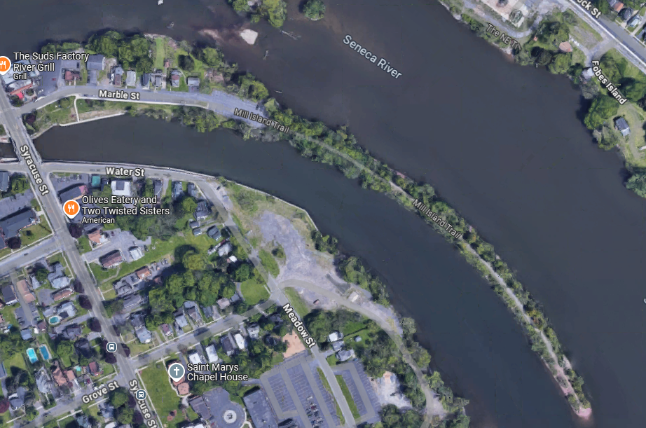

2030- Southwest Trail Extension – Connect existing Southwest trail to the Riverview Cemetery via a paved ADA accessible trail extension through NYS Canal Corporation land.

