Community Development Grant Five Year Plan

Village Objective: The village seeks to have a more scenic experience that is accessible to both community members inside and outside our village. By improving our existing infrastructure and interconnecting them all via paved and ADA accessible walking paths we can better strive towards that goal. Please find below projects that seek to improve accessibility to village trails and park land, improve village park infrastructure, and a plan to connect underserved sections of our community via a trail extension.

2027- Installation of Security cameras and access control on Paper Mill Island. With the village’s promotion’s vendor committed to 34 events per season, foot traffic to the amphitheater and park will increase due to greater community exposure. With the senior housing located right next to Paper Mill Island this demographic’s use of the park is ongoing throughout the season. The village would like to ensure a safe and controlled environment for all citizens while also maximizing all the great potential that Paper Mill Island has to offer the community, both economically and socially.

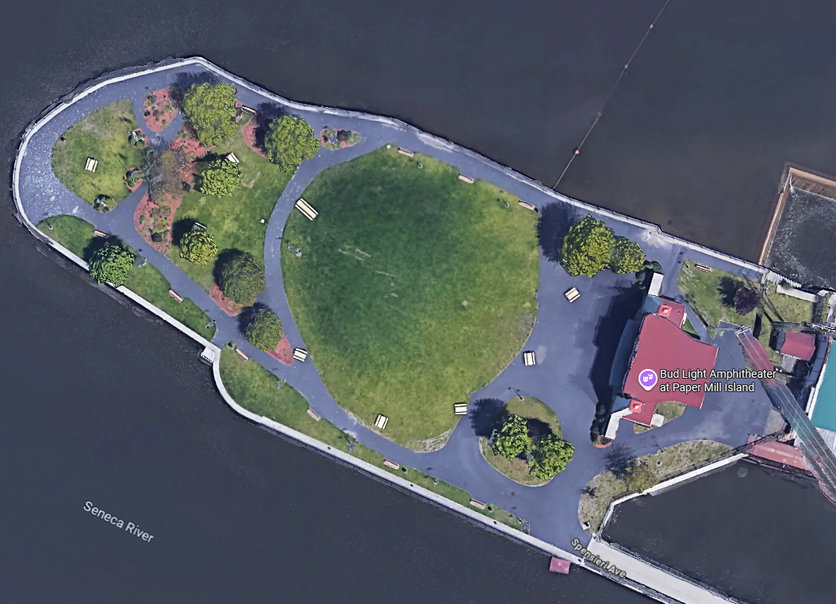

2028- Remove and replace existing playground equipment at McHarrie Park. Add ADA accessible fixtures, pathways and equipment for a more inclusive community playground experience.

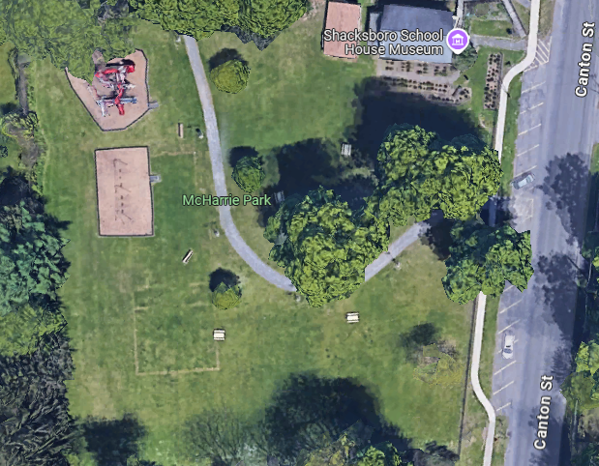

2029- Repair Roof on Amphitheater at Paper Mill Island. Roof has been leaking for 3 years and needs inspection and at the minimum a patch to stop the water infiltration.

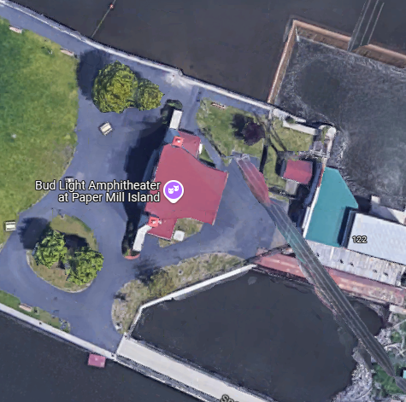

2030- Mill Island Trail Rehabilitation. Cut back overgrowth in trail, regrade uneven walking surfaces, bring trail to current ADA standards and pave.

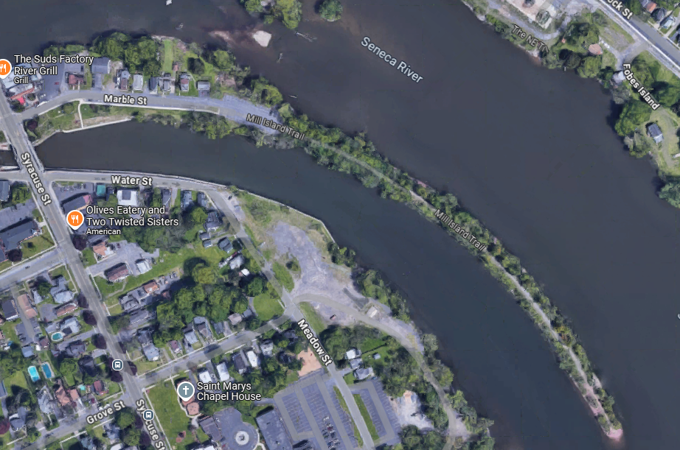

2031- Southwest Trail Extension – Connect existing Southwest trail to a planned sidewalk on Gentry Street via a paved ADA accessible trail extension through Riverview Cemetery.

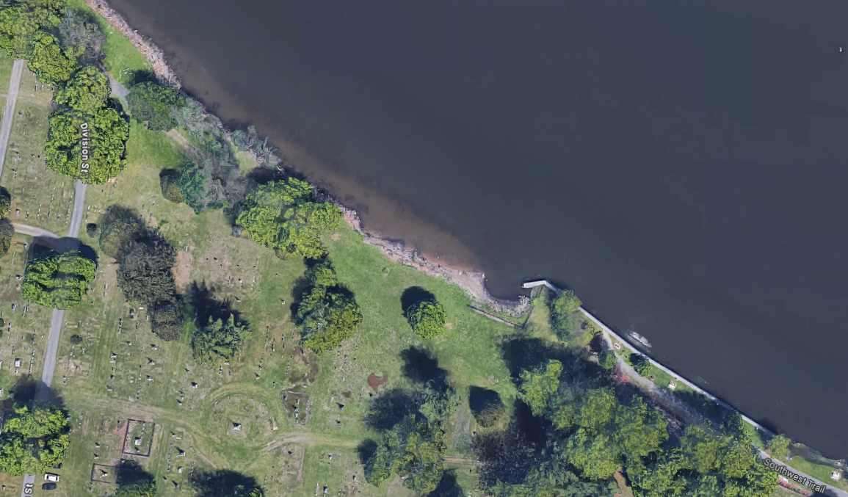

2032- Lock Street Sidewalk Extension – Install ADA traversable sidewalks on the southerly side of Lock street. Sidewalks would allows that residents on Lock street and surroundings areas to safely access the four corner business areas and connect to other village trail networks.
